Name: __________________

Goals: Master concepts of tree ID by generating a dichotomous key for a list of trees

Objectives:

1. Produce a dichotomous key that successfully separates conifers from one another.

**Background:**

A foundation in pest management is understanding the hosts for which a pest may infect. Sometimes pests are species-specific, and sometimes they are group-specific. For example, the Spruce beetle (*Dendroctonus rufipennis*) attacks all spruce (*Picea)* species. Thus, distinguishing groups of trees based on characteristics is helpful for pest management, especially in any region where you are unfamiliar with the trees.

Today, we will practice this concept by writing our dichotomous key. We will use dichotomous keys in this class for IDing insect and fungi groups later in the semester, so starting with plants is an excellent practice opportunity.

**Exercise:**

Use the attached map to find the six trees that are flagged with orange flagging. Each flag is labeled with the correct tree letter, so verify you are at the correct tree based on the flagging label.

For each tree, measure a variety of traits using the provided rulers. Some example traits may be leaf length, leaf number, maybe something about cones… etc. You may also want to record general descriptive observations (are the cone bracts stiff or soft?). I would suggest producing a data table on the back of this page to track your measurements. Is one measurement enough? Probably not. I would be sure to measure at least ten replicates from the same tree to ensure you have enough data representing **the variation** in your measurements.

Once you have recorded your data, you can begin trying to make a dichotomous key (see the example below). The goal is too separate all six species from one another. Your datasheet is worth 5 points, your key is worth 12 points, and you get three bonus points for being happy tree nerds. **Bonus:** Do you know the species name instead of just “Tree A”? Write the species name and I will reward one bonus point if you are correct. **Bonus:** can you identify genus or family splits on your key? I will reward a bonus point for each accurate genus or family split.

Example key:

1a. Leaves simple….. 2

2a. Leaves 2-5 cm…. **Tree C**

2b. Leaves 7-12 cm… 3

3a. Flowers perfect… **Tree A**

3b. Flowers imperfect... **Tree D**

1b. Leaves compound…. 4

4a. Leaves Pinnately Compound… **Tree B**

4b. Leaves Palmately Compound… **Tree E**

<Page Intentionally left blank for your creative minds to create a data sheet>

< Page intentionally left blank for you to write your key here >

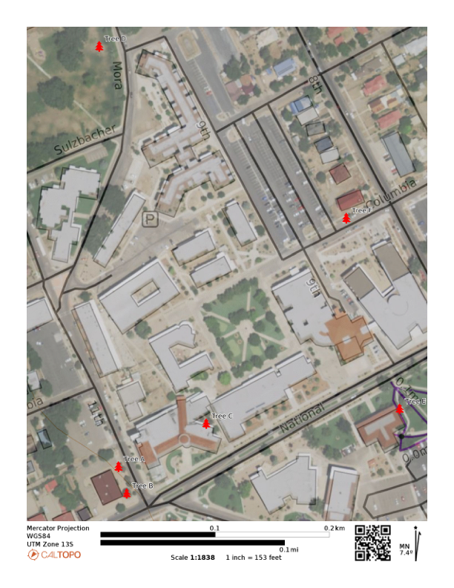

Figure 1. Map of the study area showing the location of six trees. Each tree can be accessed on sidewalks or public parks on the NMHU campus. Please avoid using private property or destructive sampling.