Name: __________________

|  |  |
| --- | --- |
| Required to complete this assignment: | A compass, a map, a smartphone, pin flags, chaining pines (2x), 50m transect tape |

**Background:** Map reading is an important foundational skill for any student of natural resource management. Today, there are many tools for field navigation, from handheld GPS units to apps and offline maps for smartphones. The foundation of all these technologies is maps.

Please see the maps at the end of this document for reference today.

By definition, maps are diagrammatic representations of an area of land (or sea) showing physical features (e.g., mountains, streams, or lakes), cities, or roads. In most instances, maps represent 3-D space on a 2-D plane (like a piece of paper).

**Question 1:** Look at the map for where we are today. Can you find a physical feature near where we are located? What about a road?

Physical feature name: _______________ Road Name: ________________

**Question 2:** In your groups, discuss an instance when either a map failed you and you were lost or unable to get to where you were going because of a map, or a situation where the map helped you when you were stuck or lost. After each person has shared a story, answer the following: What utilities do maps provide? How do you use maps in your own life?

_______________________________________________________________________________________________________________________________________________________________________________________

|  |
| --- |
| **The next page has useful definitions for the remainder of today’s exercises. Please review these terms now. If someone is not familiar with these terms, someone who is, try to explain them.** |

Useful Definitions

|  |  |  |
| --- | --- | --- |
| **Term** | **Definition** | **Additional Resources** |
| Map scale, or cartographic scale | The ratio of the distance on Earth compared to the distance on a map. A common map used is the United States Geologic Survey 1:24000 Quadrants. The 1:24000 represents a fractional scale, where one unit on the map represents 24,000 units on Earth. So, one inch on the map represents 24,000 inches on Earth. | [Download Digital USGS Maps](https://ngmdb.usgs.gov/topoview/viewer/#4/40.01/-99.93) |
| [Video about scales](https://www.youtube.com/watch?v=6XpBX-7cDPE) |
| Coordinate System | A method for identifying the location of a point on the Earth. The most commonly seen are Latitude and Longitude. There are other common systems that your GIS classes will share. Hint: Think ‘X’ and ‘Y’ axes on a graph. | [Video about coordinate systems](https://www.youtube.com/watch?v=ggdR9YAVshQ) |
| Latitude | The angular distance measured north or south from the equator in degrees. Hint: The ‘Y’ axis of our coordinate system | [Latitude and Longitude Video](https://www.youtube.com/watch?v=lUMlmRzkuuY) |
| Longitude | The angular distance measured east or west of the prime meridian at Greenwich, England in degrees. Hint: The ‘X’ axis of our coordinate system. |  |
| Magnetic North Pole | The point in which the Earth’s magnetic field points straight down, when not at this point the magnetic field points to this point making the point magnetic north. | [Earth's magnetic poles](https://study.com/learn/lesson/magnetic-poles-overview-examples.html) |
| Compass | An instrument containing a magnetized pointer that shows the direction of the magnetic north. | [How does a compass work](https://www.youtube.com/watch?v=LroX6ThIDpw) |
| Declination | The difference between geographic North and Magnetic North from any point on Earth is measured in degrees and varies based on location. | [Magnetic declination explained](https://www.ncei.noaa.gov/products/magnetic-declination) |
| Compass Bearing | A specific angle between 0° and 359.9° where 0° = North, 90° = East, 180°= South, and 270°= West. See Figure 1. | [Compass Bearings explained](https://www.youtube.com/watch?v=Jj4qOceUdt0) |
| Aspect | The compass orientation of a slope. Hint: If you poured water on a slope, which way would it flow? Face that direction and record a compass bearing |  |
| Contour Lines (Topo Lines) and Intervals | Contour lines, also called topographic (or topo) lines, represent lines of equal elevation above sea level and contour interval is the amount of elevation between contour lines. |  |
| Cardinal Direction | Cardinal directions are the main bearings; North, South, East, West. Intermediate directions are NW, SW etc. |  |
| Azimuth | Azimuth refers to an angle from you to another object in degrees |  |

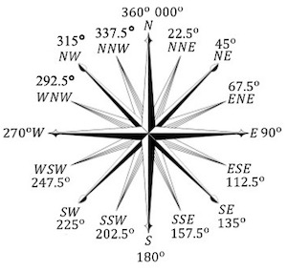

Figure 1: Standard compass bearings in 22.5-degree intervals to show the main bearings (N, S, E,W). These provide general bearings, however, in field navigation and forestry we will use bearings that are more precise by using our compass.

**Activity: Compass Bearing and Aspect**

Question: Discuss with your group what aspect means. Reference the above definitions and write your own definition of the aspect below. Come up with at least two reasons why understanding the aspect is important.

_______________________________________________________________________________________________________________________________________________________________________________________

**Using your Compass:**

|  |
| --- |
| Using your compass |
| 1. Stand holding the compass level so you can easily see the orienting arrow |
| 1. Rotate the azimuth ring until the red magnetic needle is inside of the red orienting arrow. Hint: “Red in the Shed” |
| 1. The number lined up with the white mark on your compass is your compass bearing |
| 1. Use figure 1 to determine what cardinal direction you’re bearing approximately is |
| 1. **Exercise**: What is the bearing from your point to Hermit’s Peak?   *Hint- Looking through the spotting notch and using the mirror to watch your compass adds precision |

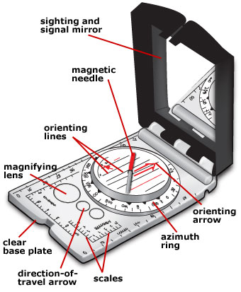

**Bearing to Hermits Peak: __________**

Figure 2: A labeled diagram of a compass

**Direction to Hermits Peak: _________**

**Activity: Slope Aspect** – In groups of two within your group, find four different slopes, each with a unique aspect, and in your pairs, identify the aspect of each slope independently. Compare your aspect to your partners. If your values were the same, congratulations! If they were different, discuss why you perhaps got different values. Return to your full group.

Question: Why might you have gotten different answers in the above exercise? Is it OK that the answers were slightly different, or is there a correct answer for the slope aspect?

_______________________________________________________________________________________________________________________________________________________________________________________

Question: Using topo lines alone, without looking at elevation values, how can you determine up-slope vs. downslope directions? Can you delineate streams, vs. ridges?

**Class Discussion:** Use the remainder of this page for any personal notes.

_______________________________________________________________________________________________________________________________________________________________________________________

_______________________________________________________________________________________________________________________________________________________________________________________

_______________________________________________________________________________________________________________________________________________________________________________________

Activity: Setting up plot centers

Directions: Navigate to your assigned initial plot. You will need to establish a total of four plots.

These plots have a random starting point established in a GIS and then will form a four-plot grid **where the 2nd plot is 50 m North of the first**, the **3rd plot is 50m east of the 2nd** , and the **4th plot is 50m south of the 3rd**. As you establish each plot, place a chaining pin at the plot center. For each plot, you will also set up a transect (see instructions below); but do not remove your plot centers so that your work can be checked.

|  |  |  |  |  |
| --- | --- | --- | --- | --- |
|  | **Group 1** | **Group 2** | **Group 3** | **Group 4** |
| Distance | 51m | 37m | 85m | 100m |
| Bearing | 206° | 281.5° | 276.3° | 218.1° |

Check your work:

|  |  |  |  |  |  |
| --- | --- | --- | --- | --- | --- |
|  | Plot 1- Plot 2 | Plot2-Plot3 | Plot3-Plot4 | Plot 4-1 | Plot 1-Plot 3 |
| Actual Distance |  |  |  |  |  |
| Actual Bearing |  |  |  |  |  |
| Theoretical Distance | 50m | 50m | 50m | 50m |  |
| Theoretical Bearing | 0° | 90° | 180° | 270° |  |

Activity: Compass bearings: Setting up a transect

A transect is a horizontal, straight line used for various vegetation sampling methods, more information on this tomorrow. Transects are compass-dependent activities and setting up a good transect also requires teamwork and coordination.

There are many ways to set-up transects; today we will learn a common and efficient approach that utilizes a plot-center and a front bearing and back bearing to establish a straight line extended equal distances from plot center.

Plot Center: New studies use random plot center locations; existing studies re-navigate to existing plot centers. Today we will use a convenient random plot center method.

Directions

1. From your established plot center ( see previous page), begin making a transect

Transect bearing: Studies use a variety of transect directions from fixed bearing – North-South or East-West to random bearings or to bearings measured in the field that represent a physical (i.e. aspect) or biological gradient. **Today, let's use a fixed North-South bearing.**

**Question:** What would the bearing read in degrees for heading North?_____

Transect length: Studies use transects in many different lengths depending on the natural range of variation and research question. Today we are using a **25 m-long transect.**

**Question:** How many meters north of plot center should you go? ______

**Think it through and communicate:** Before you start doing the next steps, think about what you need to do and communicate with team members. Designate roles, assess the transect line for potential obstacles and strategize as appropriate.

Directions Continued

1. Have one person stand at the plot center with their compass sighting north. *note: chaining pins are magnetic and can distract your needle
2. This person should direct someone else to walk due north from the plot center. *note: the goal is a **straight line**
3. Have another person follow the sighter's directions to pull the transect; **how far?** Use a chaining pin to stake the end
4. Repeat this process for heading south of plot-center
5. How will you sight south? Hint: There are at least two ways

**Use the table below to check your work. Once you are satisfied with your transect line and straightness, have Dr. Remke initial this table**

|  |  |  |  |
| --- | --- | --- | --- |
| **Check your Work** | | | |
| Measurement at plot center | Measurement at north end | Measurement at south end | Transect Bearing |
| m | m | m | ° |

Class Discussion:

_______________________________________________________________________________________________________________________________________________________________________________________

_______________________________________________________________________________________________________________________________________________________________________________________

_______________________________________________________________________________________________________________________________________________________________________________________

Activity: Map Reading

Revisit Hermits Peak. Find the summit on the map provided and find your current location on the map provided. Hint: To find your position, we need to triangulate our location. Triangulation uses three known points and bearings to draw lines on the map. Where they intersect is your location.

|  |  |  |
| --- | --- | --- |
| **Steps to triangulate** | | **Resources** |
| 1. Bearing to Hermits Peak | Once you have a bearing to Hermits Peak: Turn your compass dial until that bearing is at the index pointer. Then, turn the compass until RED is in the Shed and the direction-of-travel arrow will be pointing along that bearing. Draw a line along the edge of the compass on your map | [Triangulation Guide](http://www.compassdude.com/compass-triangulation.php) |
| 1. Bearing to Tecolote Peak | Once you have a bearing to Tecolote: Repeat the above step |
| 1. Bearing to third landmark. | Repeat the above step for your third landmark. |
| Where the three lines intersect should be the approximate location of where you are! | |  |

Now, using the map scale, calculate the distance to Hermit Peak.

Answer: ________________ Hint: Be sure to include units.

Modern and Electronic Tools:

For those who could download CalTopo and open the map sent by Dr. Remke, open the map and begin exploring the features.

<https://caltopo.com/m/8TF05>

Can you figure out how to measure the distance to Hermit Peak? If so, is it similar to your previous answer?

The GPS in your phone works by the same method of triangulation that we used, except it uses three satellites (or more) to triangulate or your position.

Geography and Place:

Using the electronic maps, turn on the layer of global imagery. Explore the map to answer the following questions:

1. Describe the relationship between the Mountains to our West and the general climate of our current location. What process or processes contribute to this relationship?

________________________________________________________________________________________________________________________________________________________________________________________________________________________________

1. Why is geography and the concept of place important in forestry?

________________________________________________________________________________________________________________________________________________________________________________________________________________________________

Grading Information On the Next Page

On this assignment, your grade is based on the total possible points, but you still receive feedback based on the written assessment rubric to help you grow as a writer.

|  |  |  |  |
| --- | --- | --- | --- |
| Points Received | Rubric Category | Rubric Score | Feedback |
|  | Knowledge |  |  |
| Total Possible Points | Skills |  |  |
| 20 | Communication |  |  |
| Points Percentage | Teamwork |  |  |
| % | Final Grade: |  | |

[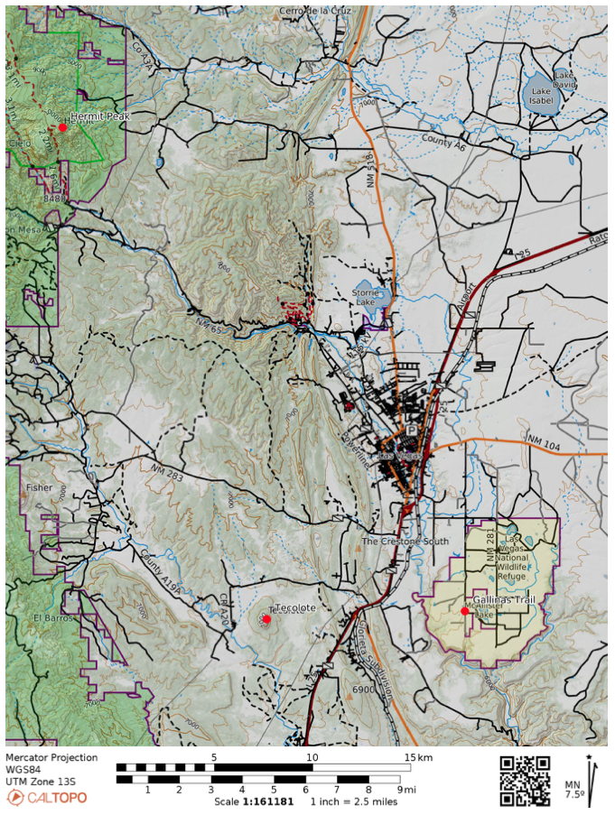](https://caltopo.com/m/8TF05)