Name:______________________.

**Soil Sampling**

The goal for this lab is to sample soils over a given area.

Why would we sample soils in a specific area?

In the space below, sketch out the different sampling designs and consider one benefit and one negative aspect of each design.

Now, we need to justify subsampling and whether to pool or composite our samples. How will we capture variability? Let’s articulate a sampling design together.

Now that we have our sampling design, let's collect our samples using soil cores. Examine the soil core. We next need to decide how deep we need to sample. Let's consider that most roots are in the top 30cm of soil. Most organic matter accumulation is near the surface, so most biological activity is in the top 10-20cm of the soil. How deep should we sample?

Our last consideration is that we need enough soil to process and analyze all of our samples.

To summarize, we will sample:

Sampling depth: _______________ in a ___________________________________________ sampling design with composite/pooled sub-samples collected.

Let’s implement our collection, with each group collecting at least one sample from each of our stratified locations for a total of _____ samples. (1 x 2 x 4groups = ________).

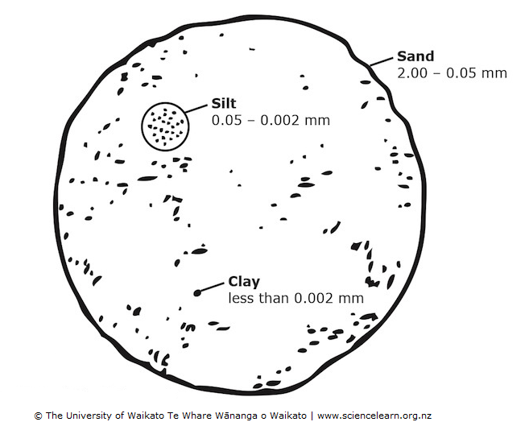

As we collect our samples, let's take one sample to quickly get a feel for soil texture. In short, soil texture is the percentage of sand relative to silt and clay, which are particles of different sizes (Figure 1).

All this talk of silt, sand, and clay, but what is loam? Loam is approximately 40% sand, 40% silt and 20% clay. But sandy loam can be up to 85% sand and equal clay and silt mixtures. These proportions of soil make a lighter, fluffy soil because of the balance of all the particle sizes.

Figure 1: Soil particle sizes

Let’s collect soil samples following our protocol. As we do this lets also set aside a small amount of soil, a quarter size ball for each person, to collect the below data points.

We will measure soil texture, infiltration rate, and color today! Based on what we observed last week, and the background information on each measurement, make hypotheses about each component for your sampling location.

Today – instead of taking the soil samples home with us, let’s just use each sample to do the below, in-field measurements.

Hypotheses:

Based on observations from last week and ideas related to soil formation environment and processes, make some hypotheses regarding the below:

HINT: read each section for some background knowledge about each metric

Soil texture

Soil infiltration rate

Soil color

Warning, you are about to get dirty!

1. At your sampling point, scrape away litter and duff and place the soil core on the soil surface.
2. Push the soil core into the soil to the sampling depth we decided on.
3. Twist the core ½ rotation in each direction and pull the soil core straight up. Empty the soil core into your hand. If we are pooling sub-samples, collect the remaining sub-samples and mix the soil into a single homogenized sample.
   1. Normally we would place each sample in a bag – note: paper bags are nice because we want the soil sample to dry and not get moldy. But a cautionary note: paper bags rip easily and then spill soil or mix soil from other samples which is very bad and confusing.
   2. We would also normally take these samples back to home away from home (the lab). But today’s goal is to learn about soil sampling. I collected samples from a graduate student’s thesis project for us to use in this class to produce laboratory data from, but the study site is too far away for us to visit.

### Soil Texture:

1. First, get a small clump of soil and place it in the ball of your hand.
2. Add a small amount of water; knead the soil into a putty.
   1. Note: if you add too much water you will end up with soup, and this is no good. Start over. Enjoy your soup.
   2. Note: If its too dry it will just be a mess of crumbs, instead of a nice ball. Add a little more.
3. Now squeeze the putty into a ball.
   1. If the soil does not make a ball and it is still wet, then the soil is sand.
4. Now place the ball between your thumb and index finger and roll the ball into a ribbon.
   1. If the soil does not form a ribbon and instead starts to crumble, its loamy sand
5. Keep forming a ribbon, noting the approximate length of the ribbon before it breaks.
6. Use the sheet on the next page to determine soil texture.

Record your soil texture for your sample on the datasheet. Remember how we stratified our sampling design? Record the soil texture for each area we sampled on the datasheet

This quick and easy method of determining soil texture is **useful** but not **precise** because it is only an estimate of texture, not an absolute. The benefit of this ribbon method is with just a little bit of water (but do not sacrifice limited, precious drinking water!), you can easily get a good idea about soil texture!

Keep this method in your back pocket so you can always critique your friend’s gardens and help them move their texture toward everyone’s favorite loam! Later in the semester, we will learn to measure the actual percentage of each particle size and define soil texture using the soil texture triangle!

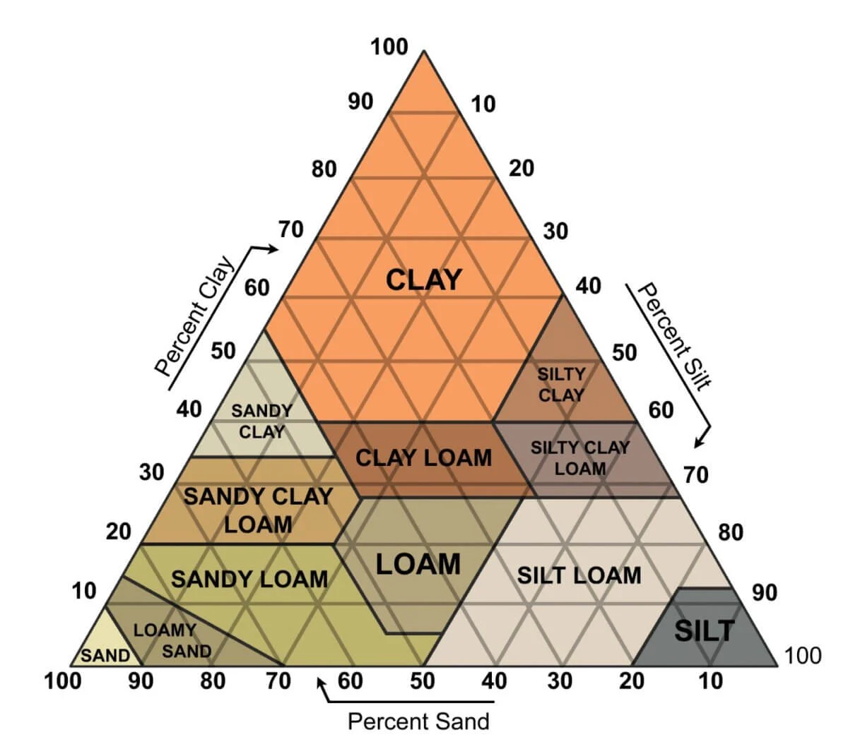

### Soil Infiltration

The faster the water seeps into, or infiltrates, the soil, the less likely water erosion will occur and the more can be absorbed by plant roots within the soil column before it evaporates away. We can this the infiltration rate.

Probably the easiest way to imagine the infiltration rate is the amount of **time** it takes for a known **volume** of water to infiltrate a known **area.**

To measure infiltration, we will use a sophisticated set of tools known as **a soil ring, a hammer, a piece of wood, a plastic bag, and a stopwatch.**

**Soil texture is the primary factor influencing soil infiltration rate, which texture do you think corresponds with higher vs. lowe infiltration rates?**

**Make a hypothesis regarding our sampling sites and infiltration rates:**

1. Using a towel on the soil surface, pour water over the soil to pre-wet the soil. We use the towel so we do not destroy any crusts on the soil surface.
2. Remove any litter and depth on the soil surface
3. Gently push the ring into the soil with your hands.
4. Using a block of wood over the ring, and the hammer, hammer the ring into the soil. We want to push the ring about 3 inches into the soil.
5. Calculate the volume of water needed to cover the ring with one inch of soil. Hint, measure the diameter of your ring. V= πr2 * h ; 1 in3 = 16.3871mL

Volume = ________________

1. Place a plastic bag in the ring and pour the above-calculated volume into the bag.
2. Gently empty the water from inside the bag into the ring.
3. Measure the time for there to be no more water on the surface of the soil. Record this time on the datasheet

### Soil color

A soil’s color can tell us quite a bit about a soil’s chemical composition and what is happening over time. For instance, dark soils suggest they have a lot of organic matter. Soils that are red in color suggest high amounts of iron and aluminum oxides and generally aerobic conditions. Soils that are grey and dull colored suggest that the soil is often saturated, causing chemical reduction.

There’s a formalized tool soil scientists use to assess soil color. It’s called the Munsell Color chart, named after the guy who developed it. It divides color into three values. **Hue, value, and chroma.**

Hue evaluates the color, value is how light or dark that color is, and then chorma is how saturated or rich the color is, as specified in the graphic below. Each page of the chart represents a different hue in the top corner, and the value and chroma vary on the y and x axes. Thus, for example, we can define a soil’s color as, 7.5YR /5 / 6, specifying value, hue, and chroma, respectively. Looking at the soil through the little hole in the chart can give you a better sense of comparison, and you’ll want to be sure to do this in good light.

Of important note:

**HUE** is color. 2.5YR (2.5 parts yellow to 1 red) or 5G (5 parts green. is pretty red; 10YR (10 parts yellow to 1 red) is more yellow…

**Value** is darkness. Values of 2-3 are darker due to the accumulation of organic materials and humus.

**Chroma** is information about brightness and dullness. Low chroma (2 or less) is grey soil, which means wet or waterlogged soil, reduction reaction environments.

Higher chromas mean more oxygen is available and oxidation reactions are occurring, oxidized and likely better-drained soil.

Instructions for soil color:

* Simply take a small piece of soil, add a small amount of water so that the soil is damp but not wet.
* Hold the soil in your hand, flip through the pages of hue in the Munsell soil color charts and look for the most similar color set
* Now begin placing the soil in the holes next to the colors that closely fit the observed color of the chart – record the hue, value, and chroma.
* Check the diagram map of the colors on the left-hand side of the page and record the Color Name.
  + NOTE: Gley is a sticky waterlogged soil lacking in oxygen, typically gray to blue-gray in color.
* Check table 1 on this document to see common minerals and their associated colors. NOTE: not every mineral will present a color because in soil these minerals will be weathered into new materials, which will have unique physical properties and colors.

HOMEWORK

1. ASAP – everyone needs to enter data into the class data sheet.

We just collected two qualitative data sets: ___________________ and _____________ one quantitative data set: ______________________.

1. Produce a write-up of these data that includes a **METHODS SECTION, RESULTS SECTION, and a brief INTERPRETAION.**
   1. The Methods Section should describe our sampling design and procedures for collecting our data in a repeatable way using complete sentences and paragraphs but not bullets.
   2. Using the whole class data, make a graph of the quantitative data set and summarize the qualitative data set for each sampling location. HINT: the frequency of each data value occurring within each group could be a great way to summarize these data. Present these outcomes in either a table or a graph. Include these graphs and tables with proper captions axis titles etc.
   3. First, just describe the results. Were there any differences in sampling locations? These should be statements that use complete sentences and are descriptive and should reference the appropriate result figure or table. :EX. Soil texture in the point bar was clay-loam in 6 of 8 samples (Table 1).
   4. Lastly, interpret the results in terms of your hypotheses. Do these findings make sense based on observations regarding depositional environments, etc?

**YOUR FINAL WRITE-UP IS DUE 9/10 and is worth 50 points. (10 methods, 10 graphs. Tables, 10 results, 10 interpretation, 10 accuracy in communicating technical information)**

**Data sheet:** [**https://livenmhu-my.sharepoint.com/:x:/g/personal/mremke_nmhu_edu/EbhcTVGyxk5Ph91w3kia9tABNhl7B5JIwmeSm3Tl4RuCMA?e=FHIxKB**](https://livenmhu-my.sharepoint.com/:x:/g/personal/mremke_nmhu_edu/EbhcTVGyxk5Ph91w3kia9tABNhl7B5JIwmeSm3Tl4RuCMA?e=FHIxKB)

|  |  |  |  |  |  |  |
| --- | --- | --- | --- | --- | --- | --- |
| Observers: | | | | Date: | | |
| Location: | | | | Site Description: | | |
| Weather: | | | |
|  | | | | | | |
| Sample ID | Sample Type | Soil Texture | Soil Hue | Soil Value | Soil Chroma | Soil Color Name |
|  |  |  |  |  |  |  |
|  |  |  |  |  |  |  |
|  |  |  |  |  |  |  |
|  |  |  |  |  |  |  |
|  |  |  |  |  |  |  |
|  |  |  |  |  |  |  |
|  |  |  |  |  |  |  |
|  |  |  |  |  |  |  |
|  |  |  |  |  |  |  |
|  |  |  |  |  |  |  |
|  |  |  |  |  |  |  |
|  |  |  |  |  |  |  |
|  |  |  |  |  |  |  |
|  |  |  |  |  |  |  |
|  |  |  |  |  |  |  |
|  |  |  |  |  |  |  |
|  |  |  |  |  |  |  |
|  |  |  |  |  |  |  |
| Notes: | | | | | | |

**Table 1: Mineral content of soil and their colors**

|  |  |  |  |  |
| --- | --- | --- | --- | --- |
| **Mineral** | **Formula** | **Size (μm)** | **Munsell** | **Color** |
| **Goethite** | **FeOOH** | **1-2** | **10 YR 8/6** | **Yellow** |
| **Goethite** | **FeOOH** | **~0.2** | **7.5YR 5/6** | **Strong brown** |
| **Hematite** | **Fe2O3** | **~0.4** | **5R 3/6** | **Red** |
| **Hematite** | **Fe2O3** | **~0.1** | **10R 4/8** | **Red** |
| **Lepidocrocite** | **FEOOH** | **~0.5** | **5 YR 6/8** | **Reddish-yellow** |
| **Lepidocrocite** | **FEOOH** | **~0.1** | **2.5YR 4/6** | **Red** |
| **Ferrihydrite** | **Fe(OH)3** |  | **2.5YR 3/6** | **Dark Red** |
| **Glauconite** | **K(SiXAl4)(Al,Fe,MG)O10(OH)2** |  | **5Y 5/1** | **Dark gray** |
| **Iron sulfide** | **FeS** |  | **10YR 2/1** | **Black** |
| **Pyrite** | **FeS2** |  | **10YR 2/1** | **Black (metallic)** |
| **Jarosite** | **KFe3(OH)6(SO4)2** |  | **5Y 6/4** | **Pale yellow** |
| **Todorokite** | **MnO4** |  | **10YR 2/1** | **Black** |
| **Humus** |  |  | **10YR 2/1** | **Black** |
| **Calcite** | **CaCO3** |  | **10YR 8/2** | **White** |
| **Dolomite** | **CaMg(CO3)2** |  | **10YR 8/2** | **White** |
| **Gypsum** | **CaSO4 x 2H20** |  | **10YR 8/3** | **Very pale brown** |
| **Quartz** | **SiO2** |  | **10YR 6/1** | **Light Gray** |