FORS 4160 – Web Soil Survey Lab

Name: ______________________

The Web Soil Survey is an online database managed by the United States Department of Agriculture (USDA) Natural Resources Conservation Service (NRCS).

Web Soil Survey (WSS) provides soil data and information produced by the National Cooperative Soil Survey. It is operated by the USDA Natural Resources Conservation Service (NRCS) and provides access to the largest natural resource information system in the world. NRCS has soil maps and data available online for more than 95 percent of the nation’s counties and anticipates having 100 percent in the near future. The site is updated and maintained online as the single authoritative source of soil survey information.

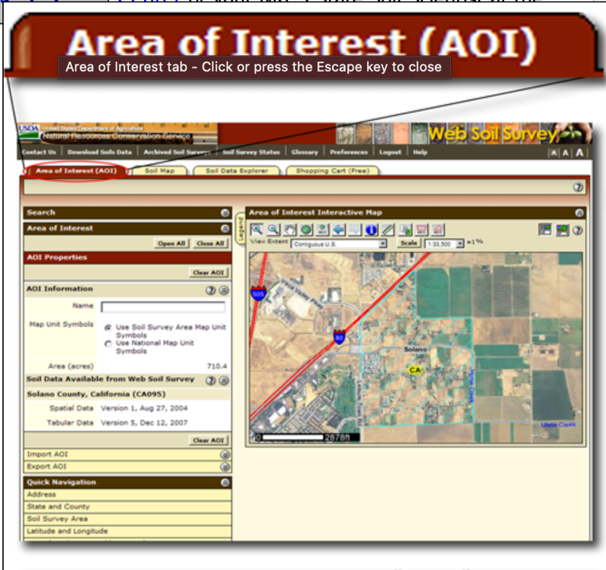Soil surveys can be used for general farm, local, and wider area planning. Onsite investigation is needed in some cases, such as soil quality assessments and certain conservation and engineering applications.

Navigate to <https://websoilsurvey.nrcs.usda.gov/app/> and click the big green button that says Start WSS.

First, define your area of interest. Be sure you are on the area of interest tab, then use the map to zoom to an area you are interested in and use the AOI polygon or rectangle tools to draw your AOI.

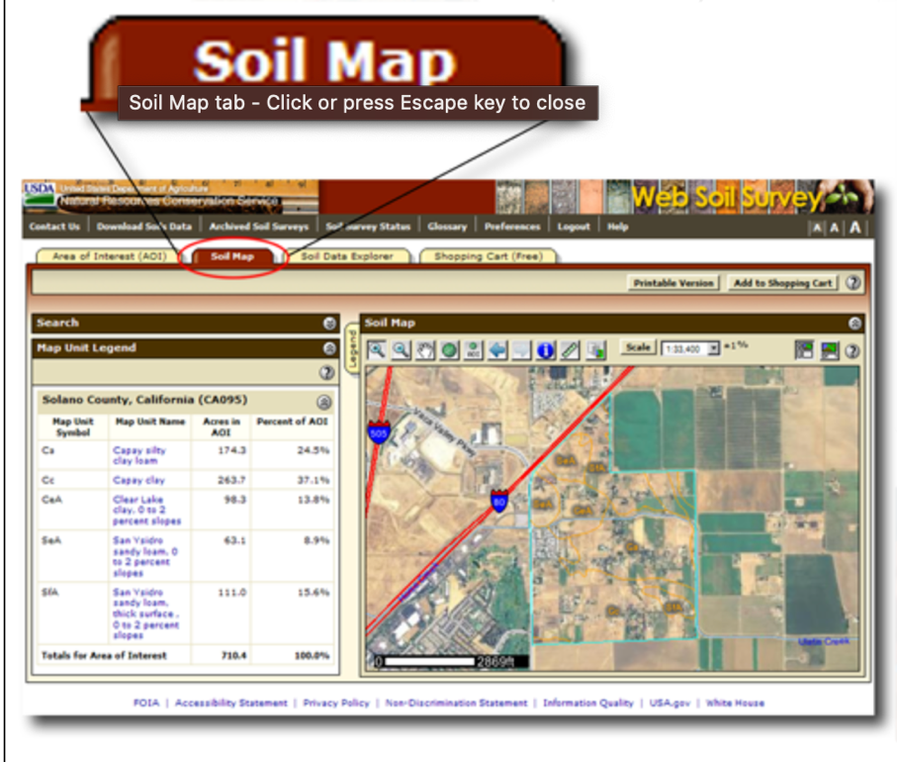Appropriately respond to any errors and adjust your AOI accordingly, if necessary.

Once your AOI has been drawn, click on the soil map tab and explore details about your soils.

For each of the map units in your AOI, write the name of each unit and click on the unit to get details. Record the following.

1. What is the name of each unit.
2. What is the temperature regime of each unit.
3. What is the parent material of each unit.
4. What is something else interesting you took note of from the map unit.

NOTE: please be sure to do this for all map units and share this information is a useful way (a table could be nice, hint hint). (double hint, do not forget a table caption).

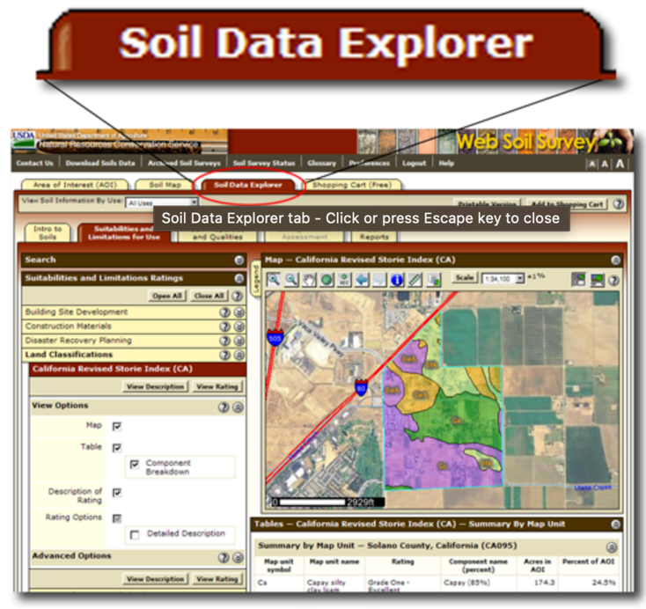Also, take a screenshot of your screen showing the map units and the map and insert this figure, including a proper figure caption.

Answer the following question:

Given the map area and the landforms in the map (ridges, valleys, etc), does the soil map line up with what you may expect? Why or why not? Please consider the soil formation process in this answer.

Next, click on the soil data explorer tab and begin exploring data to answer the final set of questions.

Explore the variety of tabs and informational tools here and consider you area of interest.

On the soil properties and qualities tab, expand soil chemical properties and select Cation Exchange Capacity and select the All Layers (Weighted Average) Radio button and then click view Description and then view rating. Select the information radio tab and see the table with the “Rating (milliequivalents per 100 gram)” column. Insert the map of soil CEC and the table of the ratings in your document.

Repeat the same process, but for percent clay under soil physical properties (insert map and table) .

In brief is there a relationship between clay content and CEC in the soils mapped in your AOI? BONUS points, if you can quantitatively demonstrate this relationship ill give you extra credit.

Lastly, insert one more table and map of your AOI that represents a variable you are interested in. Be sure to clearly state what variable this is.

What is the light it and log it loop hole?

Do you think forests or other non-human values have “rights”? If you think so, How would we implement policy and law that honor these right? If you do not think non-human values have rights, why not? How are these entities different than human entites?