Name: __________________

There are numerous ways to rate and quantify mistletoe infection within trees. The most commonly used is called the **Hawksworth six-class dwarf mistletoe rating system.**

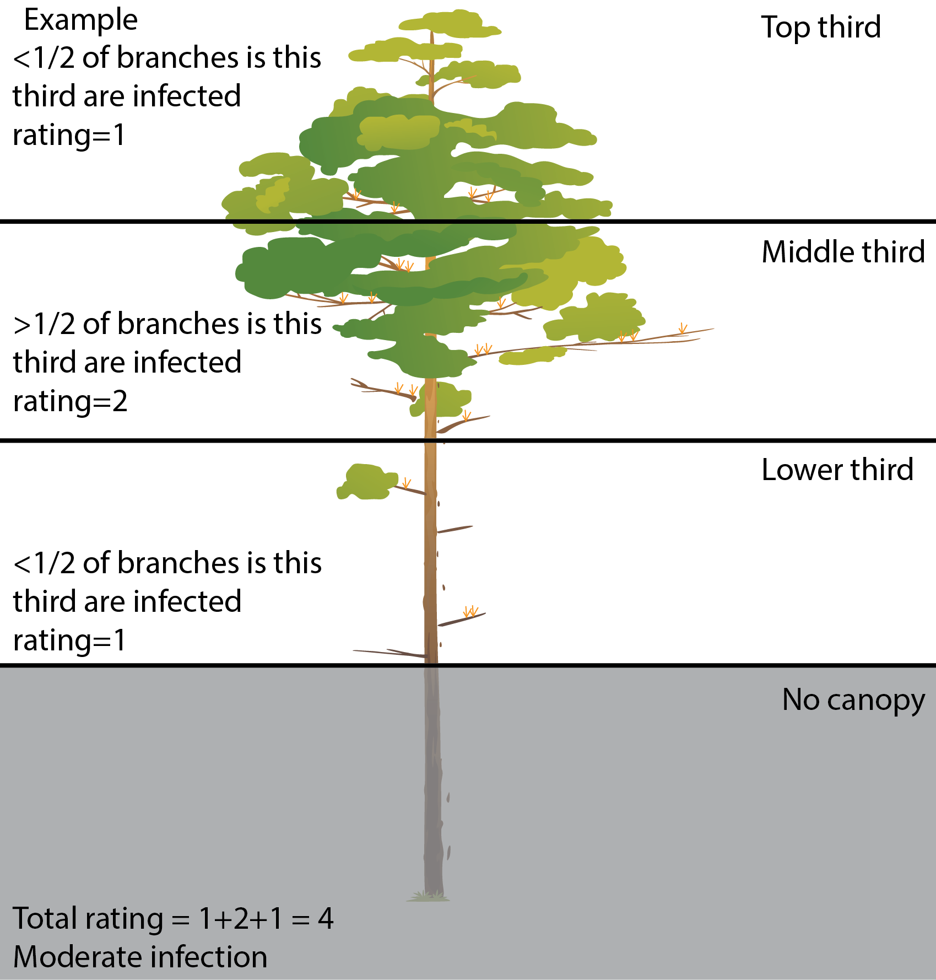Instructions:

1. Divide the crown into thirds. Include lower branches even if they lack live foliage.
2. Rate each third separately based on the following scores
   1. (0): no visible infections
   2. (1): light infection (1/2 or less of total number of branches in third infected)
   3. (2): heavy infection (more than ½ of total number od branches in the third are infected
3. Add ratings to obtain rating for total tree (between 0 and 6).
   1. Rating of 0 = **No infection**
   2. Rating of 1 to 2 = **light infection**
   3. Rating of 3 to 4 = **moderate infection**
   4. Rating of 5 to 6 = **Severe infection**
4. Stand average can be calculated by calculating the average for a stand or plot.
5. Incidence = the percentage of susceptible trees infected by dwarf mistletoe

|  |  |  |  |  |  |
| --- | --- | --- | --- | --- | --- |
| Tree Information | | Mistle toe information: | | | |
| Tree # | Tree Species | Canopy Layer 1 | Canopy Layer 2 | Canopy Layer 3 | Overall Rating |
|  |  |  |  |  |  |
|  |  |  |  |  |  |
|  |  |  |  |  |  |
|  |  |  |  |  |  |
|  |  |  |  |  |  |
|  |  |  |  |  |  |
|  |  |  |  |  |  |
|  |  |  |  |  |  |
|  |  |  |  |  |  |
|  |  |  |  |  |  |
|  |  |  |  |  |  |
|  |  |  |  |  |  |

Average rating for plot: _________ Incidence Rate: ________________

Mistletoe species observed: _______________

Based on your data:

1. Describe the degree of infection based on the average mistletoe rating and the incidence rate.
2. Describe suggested management actions to address the forest health concerns based on mistletoe infection. Feel free to include other considerations such as fire or insects/fungi.