Name: __________________

Required to complete this assignment: | Your experiences and knowledge; your personal goals from the syllabus

This is a pre-course assessment of where you currently sit with your knowledge of forestry field safety and practices. We will reassess our progress halfway through and after completing the course. It aims to be a tool to help track progress. You are evaluated on the completeness of answers, not whether the answers are correct.
Hint: Writing “I do not know” is better than writing nothing. It shows you thought about it. Hint 2: Complete sentences, please

Part 1: Forestry Safety and Field Practice: Knowledge and Skills
- In writing a field safety plan, what elements are essential to include?

- What are at least two physical features that influence the weather? Briefly describe each of these features' overall impact on weather. Lastly, how will these weather phenomena influence your decision-making in field settings?

- How are plant communities formed?

- You find a flower with a distinct banner and keel; what plant family is it in? (see photograph)
Banner

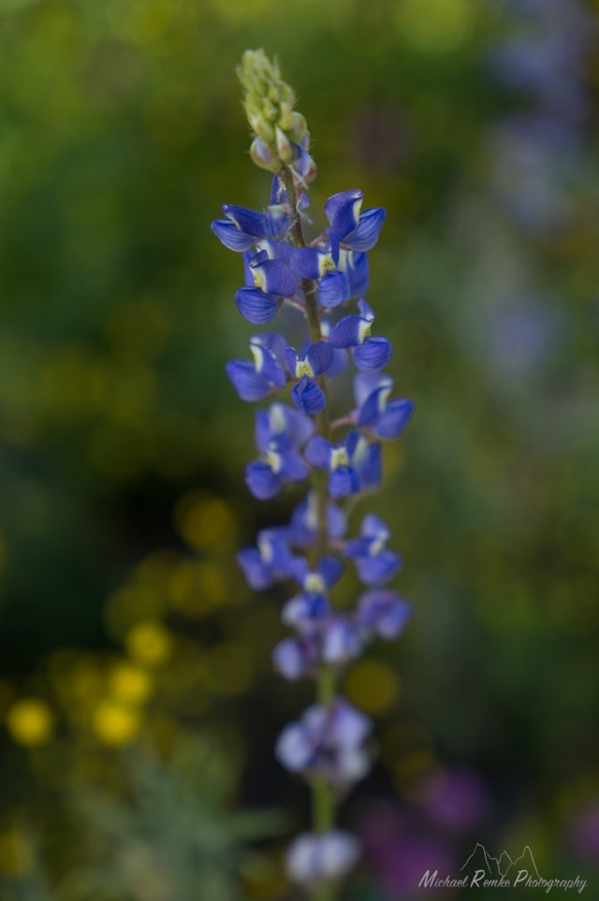
Keel

- Describe a technique that can help slow erosion in watershed restoration. Include enough detail that someone can apply this technique.

- What is the importance of geography in Forestry?

- You found someone on the ground, they are pain responsive. You find blood on their hat. What medical concerns do you have and what is your treatment plan?

- What is the purpose of doing a stand assessment? What traits will you measure in a stand assessment and why?

- How do you tell the difference between true firs and Douglas fir?

- Name three pine species found in Northern New Mexico. Use common and Latin names. Also include traits that distinguish them from one another.

- Briefly describe the difference between fixed radius and variable radius plots and why you would choose one over the other.

- What aspects of forestry are you most excited to use in your own life?

Part 2: Personal Goals and Learning
Your syllabus included space to write up to 5 personal learning goals. Please write any goals you wrote down here, then proceed to the questions on the following page.

- 1.______________________________________________________
- 2. ______________________________________________________
- 3. ______________________________________________________
- 4. ______________________________________________________
- 5. ______________________________________________________

For each question, rate your answer using the appropriate value where 1 = strongly disagree and 2 = strongly agree. Please fill in or circle the most appropriate answer. Add additional comments if you would like.

- I feel confident in the field of forestry
1 | 2 | 3 | 4 | 5
Strongly Disagree | Disagree | Neutral | Agree | Strongly Agree

Comments: _______________________________________________________________________________________________________________________________________________________________________________________

- I feel confident in field methods and data collection
1 | 2 | 3 | 4 | 5
Strongly Disagree | Disagree | Neutral | Agree | Strongly Agree

Comments: _______________________________________________________________________________________________________________________________________________________________________________________

- I feel confident working with analyzing data and interpreting results
1 | 2 | 3 | 4 | 5
Strongly Disagree | Disagree | Neutral | Agree | Strongly Agree

Comments: _______________________________________________________________________________________________________________________________________________________________________________________

4. I am confident in my written communication skills
1 | 2 | 3 | 4 | 5
Strongly Disagree | Disagree | Neutral | Agree | Strongly Agree

Comments: _______________________________________________________________________________________________________________________________________________________________________________________

5. I feel able and excited to work with others to solve problems in forestry
1 | 2 | 3 | 4 | 5
Strongly Disagree | Disagree | Neutral | Agree | Strongly Agree

Comments: _______________________________________________________________________________________________________________________________________________________________________________________

6. I feel like a valued and respected member of a community in forestry
1 | 2 | 3 | 4 | 5
Strongly Disagree | Disagree | Neutral | Agree | Strongly Agree

Comments: _______________________________________________________________________________________________________________________________________________________________________________________

Grading Information on the Next Page
On this assignment, your grade is based complete and through answers, but you still receive feedback based on the written assessment rubric to help you grow as a writer.

Points Received | Rubric Category | Rubric Score | Feedback
 | Clarity
Total Possible Points | Organization
20 | Mechanics
Points Percentage | Creativity
% | Final Grade:

