Name: __________________

|  |  |
| --- | --- |
| Required to complete this assignment: | Hand lens, flora, and plant family guides, field notebook, bird guide pin flags, chaining pins transect tape, observation to detail |

**Background:**

Natural history is a critical component of ecological and forestry-based studies. Today’s activity will focus on making observations related to the difference between qualitative and quantitative observations. We will also reflect on ways of knowing.

Activity:

Tree Identification

In your group, review the key **diagnostic traits** of the below genera.

Remember, **diagnostic traits** should be unique to that group and clearly distinguish the tree from other groups.

**Hint:** Field guides often outline these traits but be sure to also interact with the plants to see and feel them. Use your words to describe them and/or draw photos.

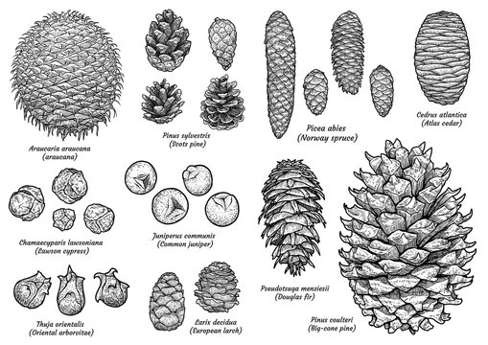

Figure 1: Can you tell these cones from one another? What traits distinguish them?

Feel free to use words or sketches.

|  |  |  |  |  |  |  |
| --- | --- | --- | --- | --- | --- | --- |
| **Genus** | **Leaf characteristic** | | **Cone characteristic** | | | **Growth form** |
| *Pinus* |  | |  | | |  |
| *Abies* |  | |  | | |  |
| *Psuedotsuga* |  | |  | | |  |
| *Picea* |  | |  | | |  |
| What traits unite all these genera? What family are they in? What traits unite this family? | | | | | | |
| *Juniperus*  *\*what family is this tree in?* | |  | |  |  | |

|  |  |  |  |
| --- | --- | --- | --- |
| **Species** | **Shade Tolerance** | **Fire Tolerance** | **Insects & Disease** |
| *Pinus ponderosa* |  |  |  |
| *Abies concolor* |  |  |  |
| *Abies lasiocarpa* |  |  |  |
| *Picea pungens* |  |  |  |
| *Picea engelamnii* |  |  |  |
| *Pinus aristata* |  |  |  |
| *Pinus*  *flexilis* |  |  |  |
| *Psuedotsuga menzesii* |  |  |  |
| *Populus tremuloides* |  |  |  |

Can you find an example of each of the above genera? Spend some time filling out the below table with additional details of some specific species.

For insects and diseases use common insects & diseases found on these trees. Hint: you can use, low, medium, and high to describe species tolerances.

Now, can you tell specific species apart from one another? Try and find example species if you can…

|  |  |  |  |
| --- | --- | --- | --- |
| **Species** | **Leaf characteristic** | **Cone characteristic** | **Growth form** |
| *Abies lasiocarpa* |  |  |  |
| *Abies concolour* |  |  |  |
| *Picea engelmanii* |  |  |  |
| *Picea pungens* |  |  |  |
| *Pinus aristata* |  |  |  |
| *Pinus flexilis* |  |  |  |
| *Pinus strobiformis* |  |  |  |

Trees are long-lived species and therefore provide numerous ideas about natural history based on the tree life history and strategy. Therefore, by looking at extant trees, we can learn about site history.

Now that you have given a little more detail about the above information for specific trees complete the questions on the next page.

**Brainstorm:**

In your groups, discuss the disturbance history of our current location. What evidence are you using to construct the history of disturbances? Can you define the below terms? If so, be sure to use these terms when reflecting on disturbance history.

|  |  |
| --- | --- |
| **Term** | **Definition** |
| Endogenous Disturbance |  |
| Exogenous Disturbance |  |
| Intensity |  |
| Severity |  |
| Frequency |  |
| Scale |  |

Activity: Quantifying other Things, starting with Birding

Thought Question: How can we quantify birds in this area? Remember that the scientific process must be repeatable. Discuss within your group and be ready to share.

Bird methods:

Quantifying Other things: Try and fill in the table for other things you could quantify in a forest. For each item, provide a detailed enough method that it is repeatable.

|  |  |
| --- | --- |
| Item being measured | Description of method |
|  |  |

**Thought Question:** Are these quantifiable methods missing any relevant information about forests? If so, what type of information can we add?

**Group Discussion:**

Disturbance History, Natural History, Ways of Knowing: Pecos

Answer the Questions on the Next Page and turn in this Assignment with your natural history write up.

1. You are hiking on a North facing slope, the forest is dominated by *Picea engelmanii* and *Abies lasiocarpa.*The understory has numerous large fallen dead trees and there are various pockets of standing dead trees with brown needles on them, but the majority of the forest is made up of large diameter, green trees. Briefly describe the site’s disturbance history. Be sure to connect evidence to describe how you know the disturbance history. Hint: discuss the scale and severity of the disturbance(s)
2. You continue hiking and start wrapping around the ridge line you are standing on. On the south facing slope the forest is dominated by *Populus tremuloides* with some *Abies lasiocarpa* in the understory. Describe this site’s disturbance history. What is the relationship of this site to the previous site?
3. Spend some time to write up a natural history of the site we visited today. Be creative. Include the species composition of the community – trees are cool, so are plants and animals. You could write in poetry format or written word. Be sure to include helpful figures (including maps or images) and a mix of quantifiable or qualifiable information as well as other knowledge (history, traditional knowledge, etc) to describe the site history. This does not need to be technical writing, but it should use complete sentences, paragraphs and flow. Spend some time making a map on the computer (CalTopo or other) is fine, GIS or Google Earth, and detailed hand-drawn maps are also OK!).

You can focus on and research any relevant aspect of the site that interests you… just be sure to include things like disturbance history (including scale and severity) as part of your site history. Use details accounts of species’ ecology to indicate likely patterns and attributes of the site.

You can write this by hand or type it on a computer.

Turn in a **printed copy or online copy (including this whole handout)** on August 5th.

Grading Information On the Next Page

This assignment has two components, the first is based on the field work assessment and is assessed below.

|  |  |  |  |
| --- | --- | --- | --- |
| Points Received | Rubric Category | Rubric Score | Feedback |
|  | Knowledge |  |  |
| Total Possible Points | Skills |  |  |
| 20 | Communication |  |  |
| Points Percentage | Teamwork |  |  |
| % | Final Grade: |  | |

The second component is the question on page 8. This question uses the written assessment rubric and is also worth 20 points.

|  |  |  |  |
| --- | --- | --- | --- |
| Points Received | Rubric Category | Rubric Score | Feedback |
|  | Clarity |  |  |
| Total Possible Points | Organization |  |  |
| 40 | Mechanics |  |  |
| Points Percentage | Creativity |  |  |
| % | Final Grade: |  | |

[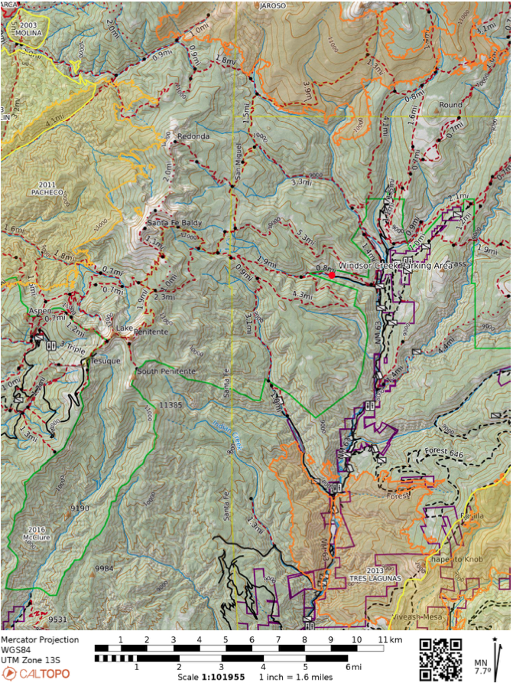](https://caltopo.com/m/J97L7)