Name: _____________________________

Soil Science: Lab 1 – Observing Soils and developing knowledge: Geomorphology

Since soils are derived from rock, and plant material, we must learn to read topography, geomorphic processes, and plant ecology in order to begin to read and understand soils.

Have you ever considered why a river meanders?

Consider physics, where the thalweg is the fastest flowing part of a river (where resistance is the least. Opposite of this fast-flowing section is a slow flowing area of deposition, called a point bar. The differential fast and slow currents within the river create bends as the fast-flowing part travels further than the slower flowing part of the river. These bends are what we call meanders. Each section of river, therefore has a different relationship with soil.

What process is occurring in the thalweg?

What process is occurring in the point bar?

What about the riffle? Hint: look at the currents in the Gallinas to see…

The study of these processes is called Fluvial Geomorphology

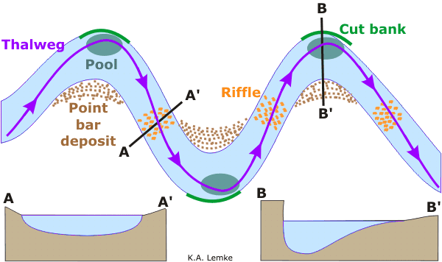

Given these dynamics, rivers create valleys by carving out an area with fluvial processes. As the valley gets carved there becomes areas of different soil environments. See if you can identify these different environments on the Rio Gallinas. Once you have, use a trowel to dig a small hole. Are the soils notably different in any way?

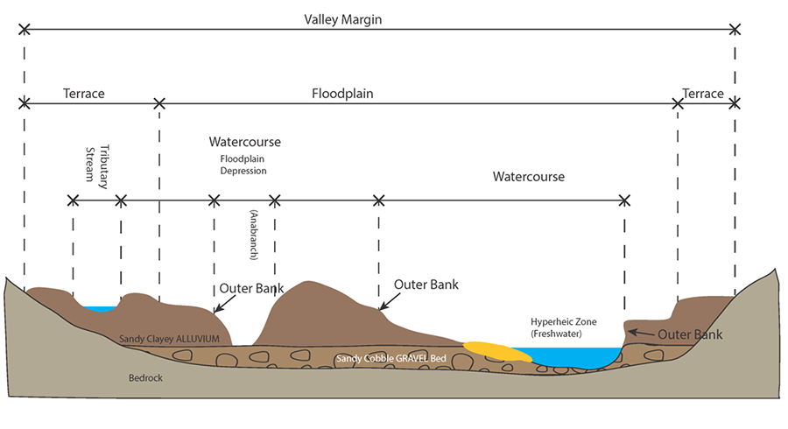

Describe the ways soil differ in these areas? Why do you think these patterns are occurring? What processes have or are contributed to these soils being different? HINT: Soil processes, or larger landscape processes. (hint, did you see the map on the next page).

Homework: How would we formally test for these differences besides walking around and grabbing soil? Or sniffing soil? What types of tests would we do? Where would we get our samples from?=

<Blank Sheet for notes etc>

