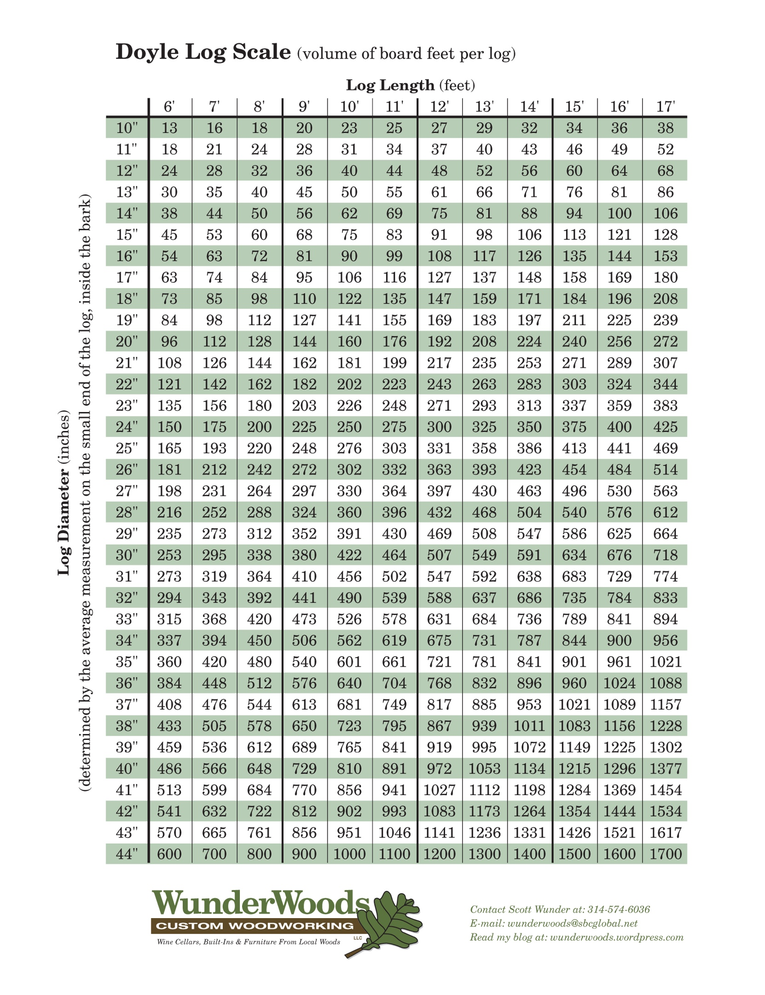
Homework: Fill in the table below using the Scribner Log Rule. Due: 08_26_2024
Name: _________________________
 | Length of Log in feet
 | 8 | 10 | 12 | 14 | 16 | 32 | 48 | 52
Diameter (in) | 10 |  |  |  |  |  |  |  | Board Feet
 | 12
 | 14
 | 16
 | 18
 | 20
 | 22
 | 24
 | 26

Answer the following questions:
You run a mill that needs to yield 750,00 board feet of wood to break even.
Using Scribner’s rule, how many trees do you need to harvest annually to break even?

Assuming an ideal tree density of 150 TPA nad an ideal rotation of 25 yerars, how many acres do you need to manage to break even?

Suppose you want to double your ROIC, from a ROIC of 1 to a ROIC of 2, now how many acres do you need to manage to break even?

