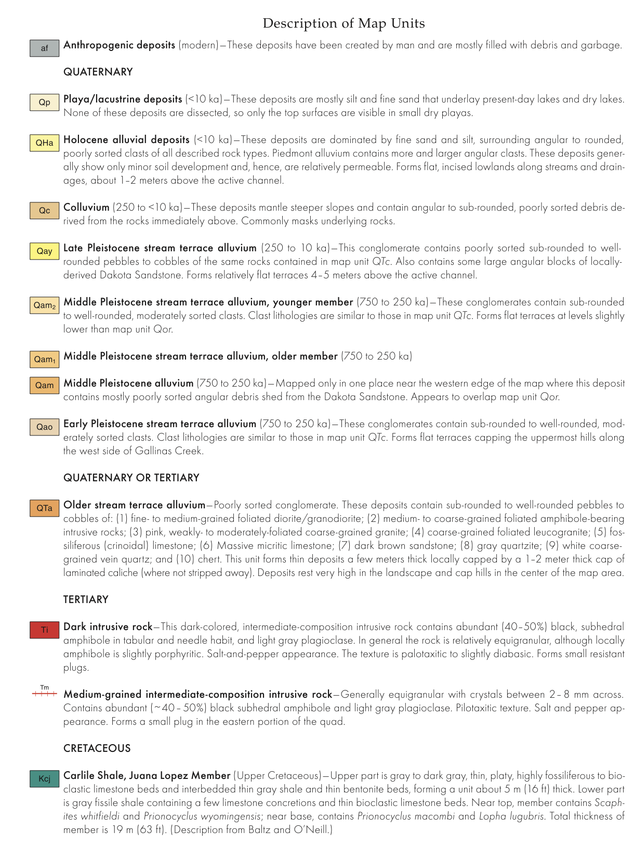

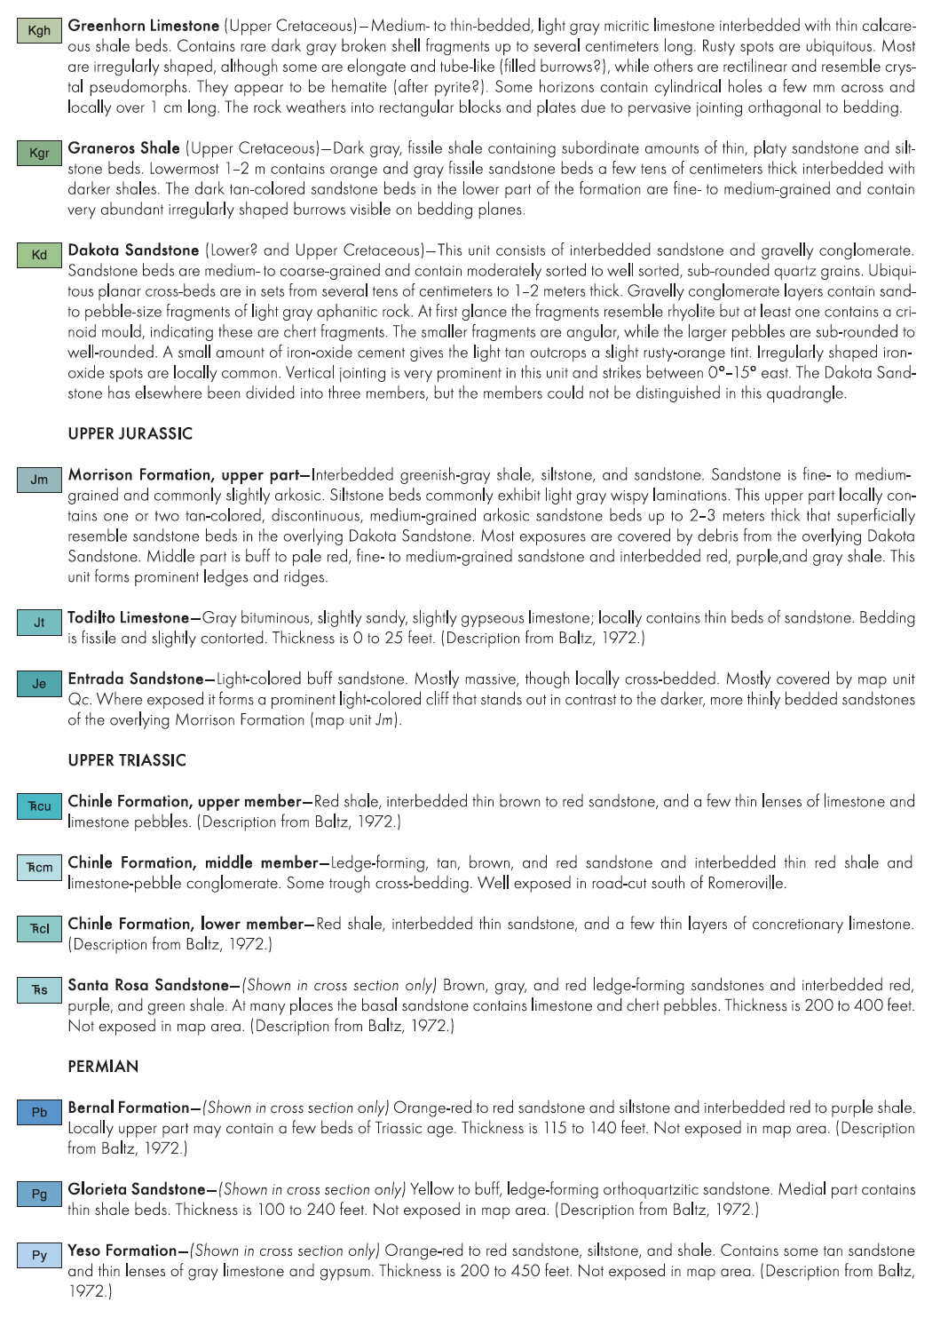

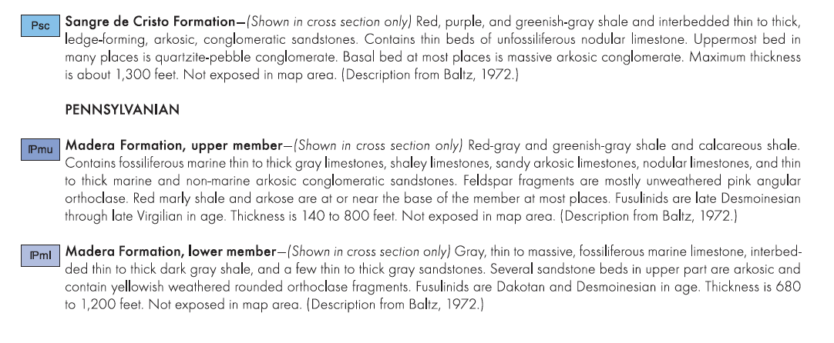

Questions:

1. Using the map below and legend above, what geologic layers are we standing on and looking at. Be sure to describe their physical location on the map or relative to us.
2. Based on these “parent materials” what would you predict soil texture to be?
3. Was your expectation about the relationship between soil parent material and soil texture true? What process could be causing divergence in grain size from parent material to soil texture?
4. Can you find evidence of the syncline (both visually and geologically)? How does orogeny influence the soil formation process?

