Name: __________________

Answer the following questions:

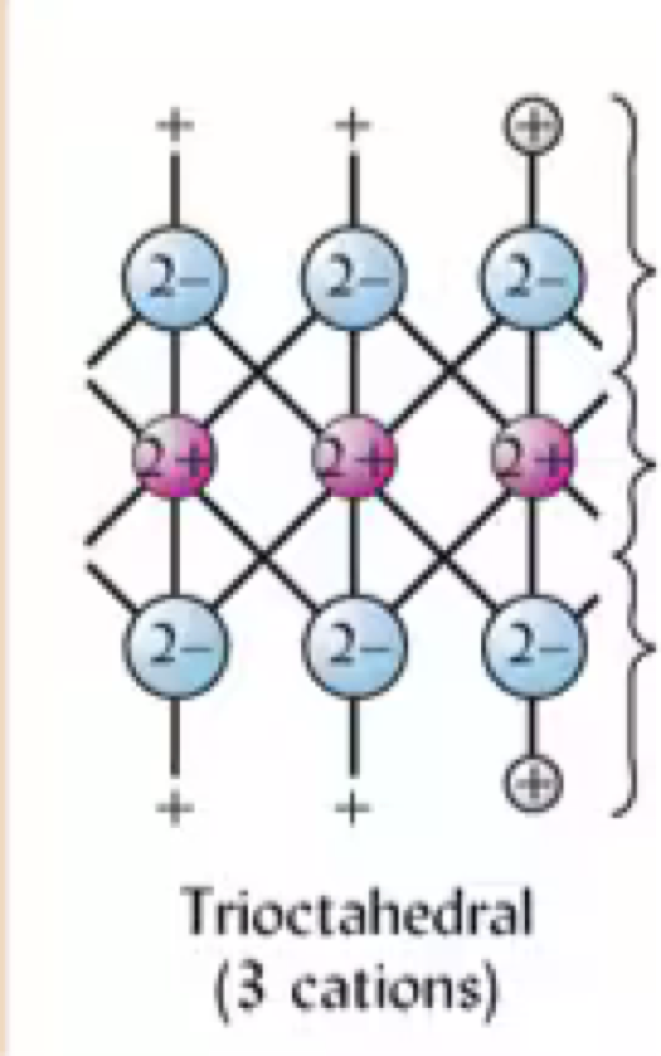

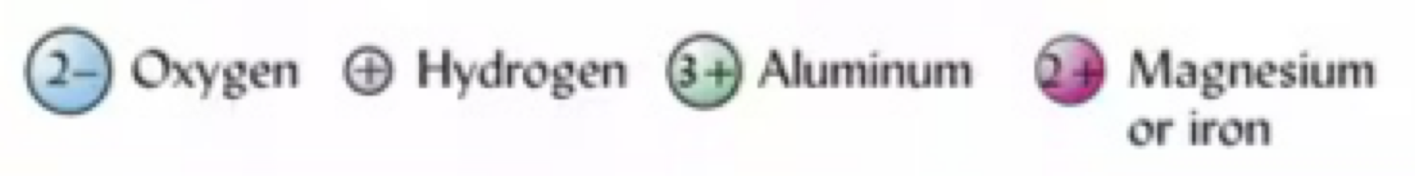 1. Calculate the charge of the terminal and central layers of this trioctahedral. What is the total net charge?

2. Describe the concept of isomorphic substitution

. 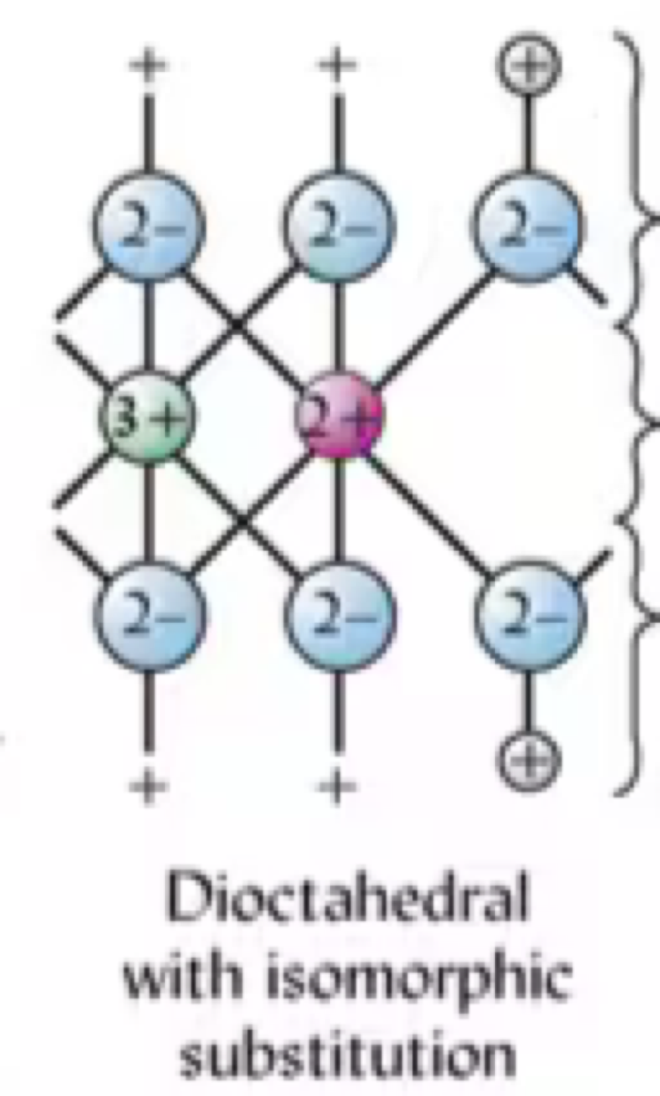

3. Given the above dioctahedral, calculate the charge of each layer and the total net charge. Of the dioctahedral and trioctahedral presented in this quiz, which is more likely to attract cations?

4. Describe what a 1:1 clay is and briefly explain properties about this clay including charge and capacity to expand

5. Describe a 2:1 clay and briefly explain properties about this clay including charge and capacity to expand